**Narala Island and** [**Pirotan**](https://www.trodly.com/destination/5019/pirotan-island)

**Pirotan Island** is one of the islands in the Marine National Park near Jamnagar district in [Gujarat](https://wikitravel.org/en/Gujarat).

Of the 42 islands, the only ones that visitors are permitted to enter and explore are Pirotan Island, which is easier to access and therefore more popular, and Narala Island, which lacks infrastructure and can only be reached at certain times, when the tide is high enough.

The islands are uninhabited except for the workers at Pirotan Islandâ€™s lighthouse, so enjoy the solitude and use it as an opportunity to lose yourself to the wide world around you. Armed with a little knowledge, you can spend hours walking around the tidal flats at low tide, observing the fascinating marine life as it lies exposed from the receding waters. Some of the creatures, such as jellyfish, are best left untouched. Be sure to ask the park officers what others should be avoided, but donâ€™t be afraid to have a hands on experience with the creatures that are open to it.

1st image :

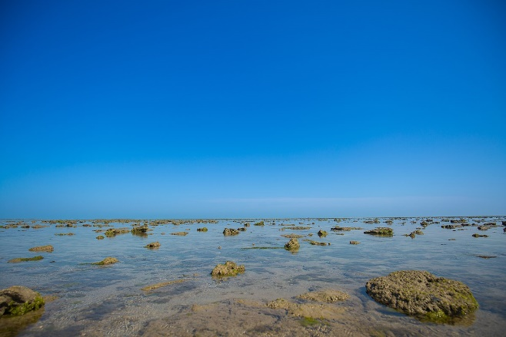

<https://upload.wikimedia.org/wikipedia/commons/thumb/6/61/The_Vast_Expanse_of_Narara_Sea_Bed_during_Low_Tide_of_Narara_Marine_National_Park.jpg/1200px-The_Vast_Expanse_of_Narara_Sea_Bed_during_Low_Tide_of_Narara_Marine_National_Park.jpg>

2nd image:

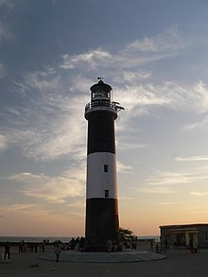

<https://upload.wikimedia.org/wikipedia/commons/thumb/3/39/Lighthouse_pirotan.jpg/220px-Lighthouse_pirotan.jpg>